**Homework 1:**

**Due 3/30 at 9 AM**

**For each of the following exercises, solve using Python in the Google Colab environment. Your homework 1 should be submitted as a pdf containing your responses, your code, and your printed results where applicable.**

**Exercise 1.**

Write your own code to produce and graph the vectors in the following figure:

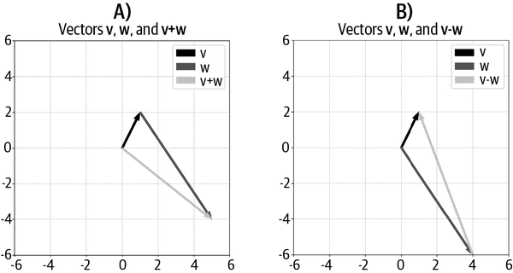

**Exercise 2.**

Write an algorithm that computes the norm of a vector by translating the following equation into code.

Confirm, using random vectors with different dimensionalities and orientations, that you get the same result as np.linalg.norm(). This exercise is designed to give you more experience with indexing NumPy arrays and translating formulas into code; in practice, it’s often easier to use np.linalg.norm().

**Exercise 3.**

Create a Python function that will take a vector as input and output a unit vector in the same direction. What happens when you input the zeros vector?

**Exercise 4.**

You know how to create *unit* vectors; what if you want to create a vector of any arbitrary magnitude? Write a Python function that will take a vector and a desired magnitude as inputs and will return a vector in the same direction but with a magnitude corresponding to the second input.

**Exercise 5.**

Write a for loop to transpose a row vector into a column vector without using a built-in function or method such as np.transpose() or v.T. This exercise will help you create and index orientation-endowed vectors.

**Exercise 6.**

Here is an interesting fact: you can compute the squared norm of a vector as the dot product of that vector with itself. Look back to the equation in Exercise 2 to convince yourself of this equivalence. Then confirm it using Python.

**Exercise 7.**

Write code to demonstrate that the dot product is *commutative*. Commutative means that

$a*b=b*a$, which, for the vector dot product, means that $a^{T}b=b^{T}a$ . After demonstrating this in code, use the following equation to understand why the dot product is commutative. A mathematical equation with numbers and symbols
